Buğra Sipahioğlu

November 12, 2019

Mehmet Gönen, Comp 421

**Homework 04 Report: Nonparametric Regression**

First of all, I’ve imported the data such that X represents eruptions and y represents waiting column. Then I’ve separated them into test and training subsets. I’ve replicated the equations in the book. All of the three functions (regressogram, running mean smoother, kernel smoother) are consist of same sub-parts. There is a nominator and denominator. Nominator always the sum of the specified function multiplied by y_train, and denominator is always the same function without multiplication. I’ve applied same pseudocode for three algorithms. Only differences were the specific functions. Here are my results, which are highly close to the ones in the homework description:

**Regressogram**



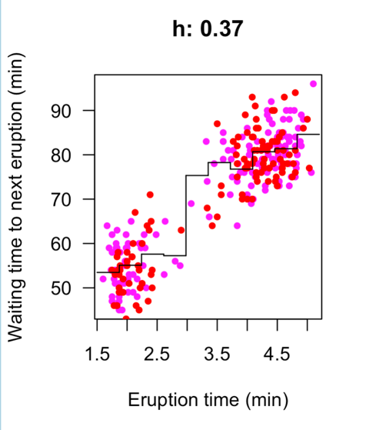

**Running Mean Smoother**

**  
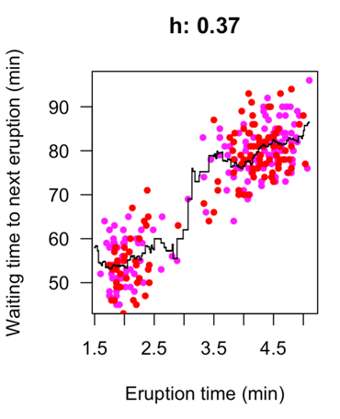**

**Kernel Smoother**



